Infusion Chippy Food Allergens

Allergens |  | Contained in these Products:
GLUTEN  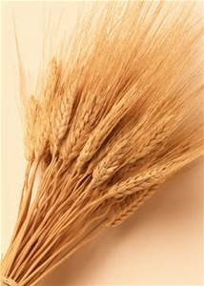 |  | - Battered Fish  Gravy  Curry Sauce  - Sausages  - Malt Vinegar (5 Litre) | - Steak Pies  - Cheese Pies  - Meat & Potato Pies  - Sausage Rolls  - Scampi
EGGS   |  | - Steak Pies  - Cheese Pies  - Meat & Potato Pies  - Sausage Rolls | - Curry Sauce
FISH  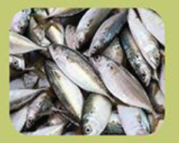 |  | - Battered Fish  - Curry Sauce
SOYBEANS  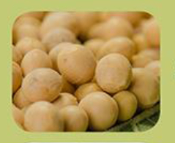 |  | - Battered Fish  - Gravy  - Sausages  - Steak Pies | - Cheese Pies  - Meat & Potato Pies  - Sausage Rolls
MILK   |  | - Cheese  - Hot Chocolate  - Powdered Milk  - Jiggers | - Cheese Pies  - Battered Fish

CELERY  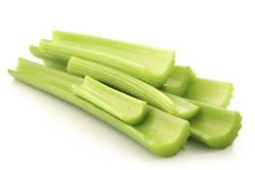 | - Curry Sauce  - Steak Pies  - Cheese Pies  - Battered Fish | - Meat & Potato Pies  - Sausage Rolls  - Rollover Ketchup
MUSTARD  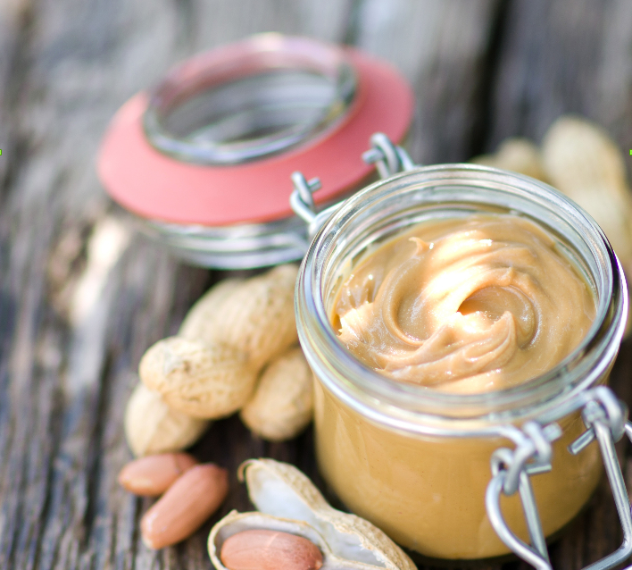 | - Battered Fish
SULPHUR DIOXIDE  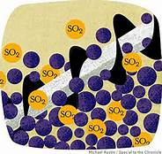 | - Curry Sauce  - All Post Mix Drinks  - Sausage Rolls  - Orange Cordial  - Blackcurrant Cordial | - Steak Pies  - Cheese Pies  - Meat & Potato Pies
Crustacean | - Scampi | - Battered Fish (During cooking)
There is a small chance that foods may come in contact with one another during preparation, which is not reflected in this table.
Although efforts are made to avoid cross - contact of allergens, we cannot guarantee that this will not occur.

