WOK Food Allergens

Allergens |  | Contained in these Products
GLUTEN  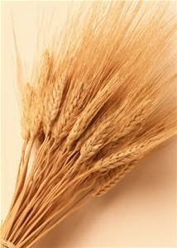 |  | - Noodles  - Black Bean Sauce  - Hoisin  - Oyster sauce  - Sweet & sour | - Soy sauce  - Gluten  - Prawn crackers
CRUSTACEANS  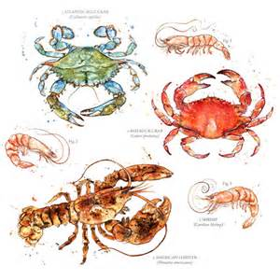 |  | - Oyster Sauce
FISH  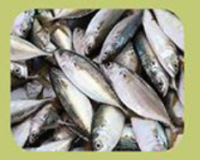 |  | - Oyster Sauce  - Black Bean Sauce  - Prawn crackers
SOYBEANS  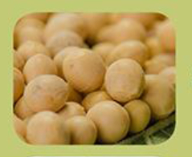 |  | - Soya Sauce  - Sweet Chilli  - Blackbean Sauce | - Hoisin Sauce  - Curry mix
MILK   |  | - Prawn Crackers  - Curry sauce
Sesame Seeds  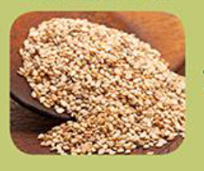 | - Hoisin  - Sweet Chilli
SULPHUR DIOXIDE  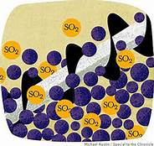 | - Bouillon Chicken  - All Post Mix Drinks  - Curry sauce
MOLLUSCS  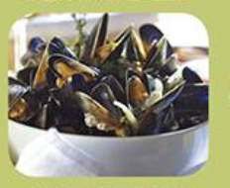 | - Oyster Sauce
There is a small chance that foods may come in contact with one another during preparation, which is not reflected in this table.
Although efforts are made to avoid cross - contact of allergens, we cannot guarantee that this will not occur.

